**Study of the impact of spaceflight on astronaut salivary microbiome**

**Jiseon Yang, Briana Paiz, Abigail Cave, Ananya Kohli**

BIO 598

Dr.Qiyun Zhu

29 April 2023

**Abstract:**

There is limited knowledge and research on the salivary microbiome of astronauts, especially in relation to microbial markers for mental health disorders such as depression and anxiety. In our study, we aim to approach two questions. Does spaceflight affect the salivary microbiome of astronauts, and are there significant changes in that microbiome from pre, during, and post-flight? In our approach, we use 16s rRNA gene sequencing data in V3-V4 regions from ​​NASA’s GeneLab repository to look at the alpha diversity, beta diversity, and the differential abundance in pre, during, and postflight for the salivary microbiome of astronauts. Our results indicated significant differences in the beta diversity of the data, as well as the differential abundance in the preflight vs during-flight samples. In that differential abundance analysis, we found four families were depleted preflight. While we found some statistically significant results in our data, the limited access to astronauts' medicine use, possible bias in sample collection, and small sample size could have influenced our results. Further research should be done in this field of study to provide insight into interactions with the host and salivary microbiome. Research in this sector may allow for the identification of health risks associated with space travel, especially with mental health disorders.

**Introduction:**

Astronauts are put through extensive training to prepare them both mentally and physically for the harsh conditions faced in space travel and life at the International Space Station. NASA identified four of the major hazards associated with space flight; radiation, isolation and confinement, distance from earth, and gravity fields. Being exposed to extremely high levels of radiation is known to cause problems with cognitive function as well as within the central nervous system (Mars 2021). Traveling in a spacecraft and living at the International Space Station require the astronauts to adapt to limited open space. Given the distance from Earth, astronauts must be prepared to handle situations in space without relying on people or resources from Earth. Traveling and living in different fields of gravity has a negative impact on the body. For example, being weightless usually results in a significant decrease in muscle mass, leading to diseases such as osteoporosis (Mars 2021). With all of these hazards and potential diseases being researched, there has been limited research on the microbiome of astronauts.

It is now increasingly recognized that microbiome studies can provide an important insight into health issues in the medical field. Therefore, looking at the microbiome of astronauts could be beneficial and provide a better understanding of what exactly is going on within the body throughout space travel. Previous studies have shown altered gut microbiota influenced by space travel, suggesting a potential association with metabolic and immune function of astronauts (Voorhies et al. 2019). However, there is still a limited understanding on how space affects the human microbiome, particularly oral microbiome. With the variety of known hazards astronauts face, there have not been many studies looking into how their mental health is affected. Two major mental illnesses, anxiety and depression, have been researched extensively. Therefore, comparing the oral microbiome of the astronauts to the oral microbiome of people diagnosed with these illnesses could provide a potential link to the relationship between space travel and anxiety and depression. A recent study found that the oral microbiome of those with anxiety and depression had specific bacteria present, such as Actinomyces and Fusobacterium (Simpson et al, 2020). Therefore, with this knowledge, we predict that space flight might lead to astronauts experiencing anxiety or depression and associated changes in their oral microbiome, like the presence of microbial communities identified in depression and anxiety oral microbiome studies.

The main objective of this study was to determine whether or not there are significant changes within the salivary microbiome of astronauts throughout the space travel journey. Three time points were analyzed, pre-flight, during-flight, and post-flight. Since only a few astronauts travel to the International Space Stations (ISS) at a time, the data collection time points varied. Astronauts collected salivary samples and the 16s rRNA sequencing data was used in order to perform analyses, looking at differential abundance and microbial diversity. It was hypothesized that long-duration space travel aboard the ISS alters astronauts' salivary microbiome. It was predicted that the during flight salivary microbiome is likely to resemble anxiety and depression microbiome and is a result of space flight associated stressors. The present study shows how the abundance of the microbial communities is more likely to drive differences between the different flight times, as compared to the diversity of the microbiome itself, and how these abundance differences could potentially drive anxiety and depression in astronauts.

**Materials and Methods:**

**Participant Information and Sequencing Data**

The data for this study was obtained from a previously conducted study investigating the influence of space flight on salivary microbiome and space reactivation (PRJNA539937). The data is also available in NASA’s GeneLab data repository under the link:<https://genelab-data.ndc.nasa.gov/genelab/accession/GLDS-280>. For the purpose of this study, the sequencing data and the sample metadata were obtained directly from NASA’s GeneLab repository.

During different space missions, saliva samples were collected from 10 different male astronauts at three time points: pre-flight, during flight and post-flight as shown in **Fig. 1A**. Including the two negative controls, 28 pre-flight, 23 during flight and 38 post-flight samples were obtained giving a total of 91 samples. The samples were collected by the astronauts themselves and frozen at -80 degrees celsius, thawed together at the time of sequencing. The V3-V4 region of the 16S rRNA was paired-end sequenced on the Illumina Mi-Seq platform. Specifically for this study, demultiplexed, paired end sequencing reads were obtained for all the samples from NASA’s GeneLab repository and subjected to quality control and statistical analyses.

**Raw Data Processing and Quality Control**

The primers were removed using the cutadapt plugin in Qiime2 (341F-5'-CCTACGGGNGGCWGCAG-3', 785R-5'-GACTACHVGGGTATCTAATCC-3'). For quality control, including chimera removal, filtering noisy sequences, removing singletons, joining denoised paired reads and deduplicating the sequences, DADA2 plugin of Qiime2 was used (Calahan et al., 2016). The result was an Amplicon Sequence Variant (ASV) table. The parameters used for filtering and trimming with DADA2 are, for forward and reverse reads respectively, trim-left (17,21), trunc-len (280,220), max-ee (2,2) and trunc-q=2. The chimeric sequences were removed using the consensus method. The parameters were chosen based on the parameters used in the space flight study from which the data was obtained.

**Taxonomy Classification and Phylogeny**

Taxonomy was assigned using the Greengenes2 reference database. Since the V3-V4 region was under study, a classifier was first trained using the entire backbone sequence from Greengenes2. Training was done using the Naive Bayes classifier in Qiime2, a machine learning method. Given the set of primers and the backbone sequence, reads specific to the V3-V4 region were extracted and were used to train the Naive Bayes Classifier. The V3-V4 region trained classifier, on the Greengenes2 reference, was used to predict the taxonomy for the ASVs. This was followed by De Novo construction of a mid-rooted phylogenetic tree using Qiime2. MAAFT was used for multiple sequence alignment. The alignment was then used by IQTree to construct a phylogenetic tree based on maximum likelihood, that optimizes for the most probable phylogenetic tree given the alignment.

**Statistical Analysis**

Statistical analyses were conducted using Qiime2. Alpha diversity was calculated using the Shannon metric which takes into account the species richness and evenness. Rarefactions were conducted at multiple sequencing depths for the three flight times and the control. A sampling depth of 4700 was decided on for rarefaction of ASVs to exclude the control samples, with a lower feature count. All the feature counts were above this sampling depth and the rarefaction curves for the Shannon metric had a plateau at this depth. Therefore, the sampling depth was likely to give the best alpha diversity results possible. Qiime2 conducted a Kruskal Wallis test to ascertain the difference in alpha diversity across the three flight times, after rarefaction, and pairwise comparison tests (post-hoc tests) thereafter. Difference was considered significant if p value < 0.05 for the Kruskal Wallis test and if the q value < 0.05 for the pairwise comparison tests. Python’s seaborn library was used to create the alpha diversity boxplot.

Beta diversity was calculated using the Weighted-UniFrac. Weighted-UniFrac considers both phylogeny and abundance of the ASVs to calculate the distance between samples. The distances were visualized using Principal Coordinate Analysis (PCoA) and the samples were colored by flight time to observe any clustering pattern in samples with respect to flight time. Adonis test (analysis of variance using distance matrix) was conducted to calculate beta diversity differences between the three groups: pre-flight, during flight and post-flight. Results were considered statistically significant if the p value < 0.05.

Given the mostly insignificant results from the diversity analyses at the genus level, differential abundance analysis at the family level was conducted to look for potential evidence of abundance driving the difference between the three flight times. This was done using ANCOM-BC (analysis of compositions of microbiome with bias correction) in Qiime2. ANCOM-BC considers the compositionality of the microbiome, specifically the sampling fraction which could create bias in differential abundance analysis (Lin and Peddada, 2020). For the analysis, during flight was chosen to be the reference and comparisons were, therefore, made between pre-flight and during flight and post-flight and during flight. A q value < 0.05 was considered statistically significant. Log fold changes between the groups being compared, with respect to the reference, were represented by the coefficients. As a further confirmation to ANCOM-BC, multiple T-tests ( Mann Whitney Test) with 5% FDR and one-way ANOVA (95% CI) were performed using Prism 9.

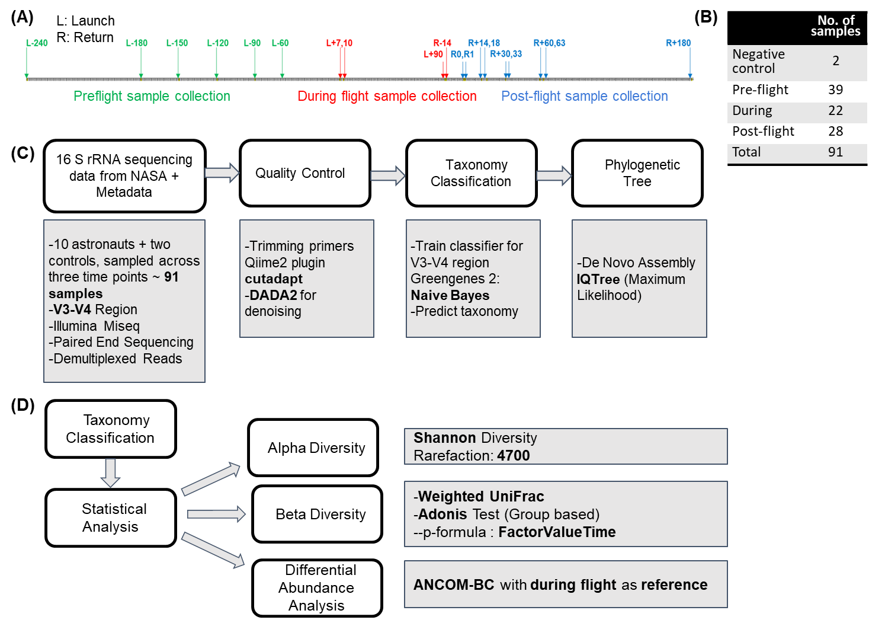

**Figure 1. Study experimental design. (A)** Timeline for the sample collection **(B)** The sample used in this study **(C)** Workflow depicting the quality control process and classification of taxa. **(D)** Workflow depicting the downstream analysis, specifically the statistical analysis conducted.

**Results**:

The taxonomic classification of the oral microbiome was conducted using a classifier trained on the V3-V4 region of the Greengenes2 reference backbone and visualized using Qiime2 at the class level as shown in **Fig. 2**. There is variation between samples and between different groups. However, qualitatively, there doesn’t seem to be any significant difference in the taxa identified across groups. Bacilli in the phylum Firmicutes was found at a relatively high frequency across the different time points. The evolutionary relationship between the taxa identified in the samples is visualized in the form of a phylogenetic tree in **Fig. 3**. To get a deeper insight into the diversity of these taxa within and across the groups, alpha diversity using Shannon’s diversity and beta diversity using Weighted-UniFrac was conducted.

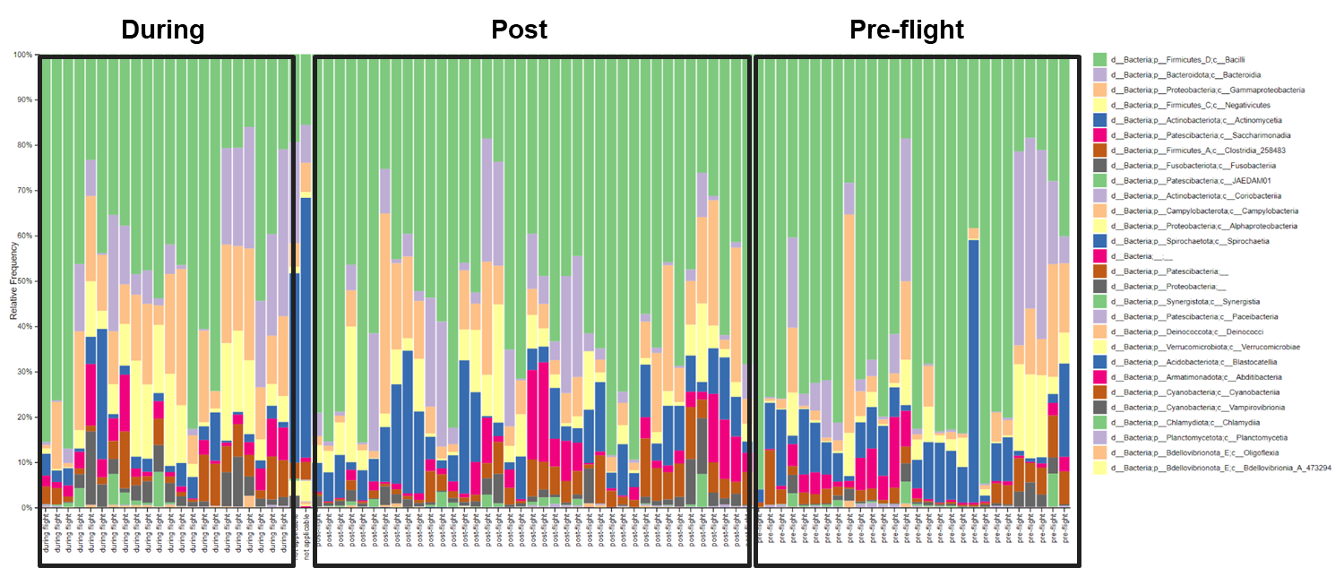

**Figure 2. Taxa Barplot.** Taxonomy of each sample, at the Class level, is shown above. Taxonomy was predicted with a classifier trained on the V3-V4 region, using qiime2 Naive Bayes, of the Greengenes2 reference and grouped based on flight time: during flight, post flight and pre flight.

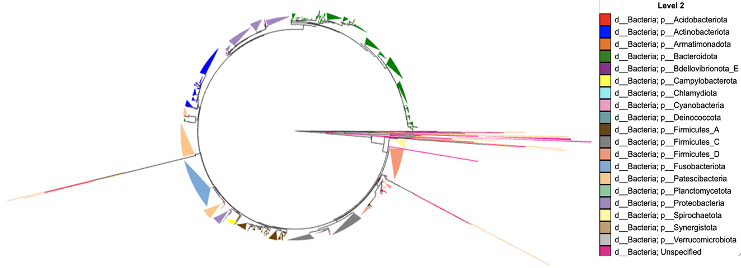

**Figure 3. Phylogenetic Tree.** Phylogenetic tree was constructed using maximum likelihood based IQTree and visualized using *Empress* at the Phylum Level. The tree was midpoint rooted.

Alpha diversity was calculated based on the Shannon entropy to get a measure of within sample and group diversity of the microbiome. At different sequencing depths, the Shannon entropy, and therefore, microbiome diversity seemed to be consistently higher for the during flight samples as compared to the preflight and postflight samples, with the two curves almost coinciding **(Fig. 4A)**. Since the diversity did not change considerably after a sequencing depth of 500, the samples were rarefied using a depth of 4700. The chosen depth enabled the exclusion of control samples from subsequent statistical analyses. When conducting the Kruskal Wallis test, non-parametric ANOVA, on the different flight groups, no significant difference between the flight groups was observed (p value < 0.05) **(Fig. 4B).** The pairwise comparisons between the different flight groups showed some difference between during flight and pre-flight groups (p value < 0.05) but loses significance when correcting for multiple testing (q value > 0.05) **(Fig. 4C)**.

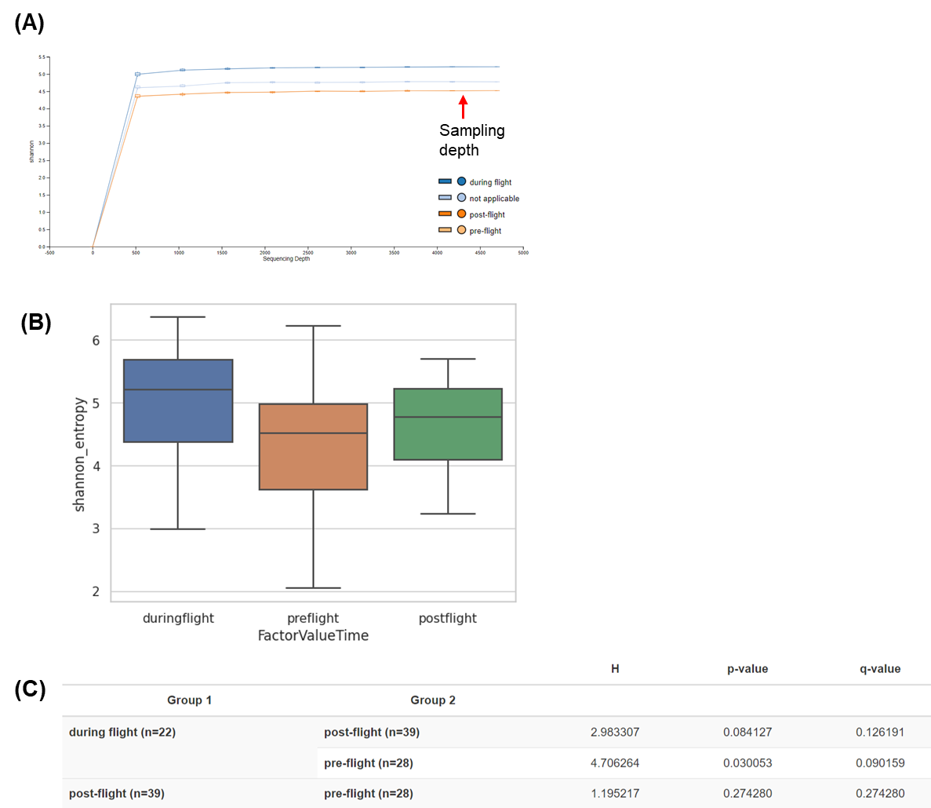

**Figure 4. Rarefaction curves And Alpha diversity. (A)** Alpha rarefaction curves generated for different rarefied sequencing depths (x-axis) and the corresponding Shannon diversity values (y-axis) for different groups are shown. The curve plateaus for all three groups (and control indicated as not applicable) at a sequencing depth of ~500. A sampling depth of 4700 was chosen for downstream analyses. **(B)** Alpha diversity, based on Shannon entropy, was conducted using Qiime2 for different flight times. No significant difference was observed between groups (Kruskal-Wallis H test: H= 5.587, p value=0.061) **(C)** Post-hoc analysis between different groups is shown. After correcting for multiple tests, no significant difference between any two groups was observed.

In order to investigate whether there are significant differences among three groups (pre-, during, and post-flight), we performed a Beta diversity test. The Anonis test results are shown in the **Fig. 5A**. The F value is representing the variance between the intergroup and intragroup. The R2 value is showing the variance between flight times and the Pr value is expressing how likely these values were obtained by chance. The data showed that the difference in beta diversity between groups is statistically significant (Pr >0.018) with about 5.5% of the variance between samples explained by the flight time. The F statistic is also more than 1, however, larger numbers for F statistic and R2 would be desirable. The compositional differences were visualized with PCoA plot using EMPeror (**Fig. 5B**). While the Adonis test showed the significant difference in beta diversity among the groups, the points are unorderly and do not show clear clustering. Additionally, a PCoA biplot was created and shows the taxa that best explain this variance between groups. The PCA components shown mostly correspond to the *Streptococcus* genus (**Fig. 5C**).

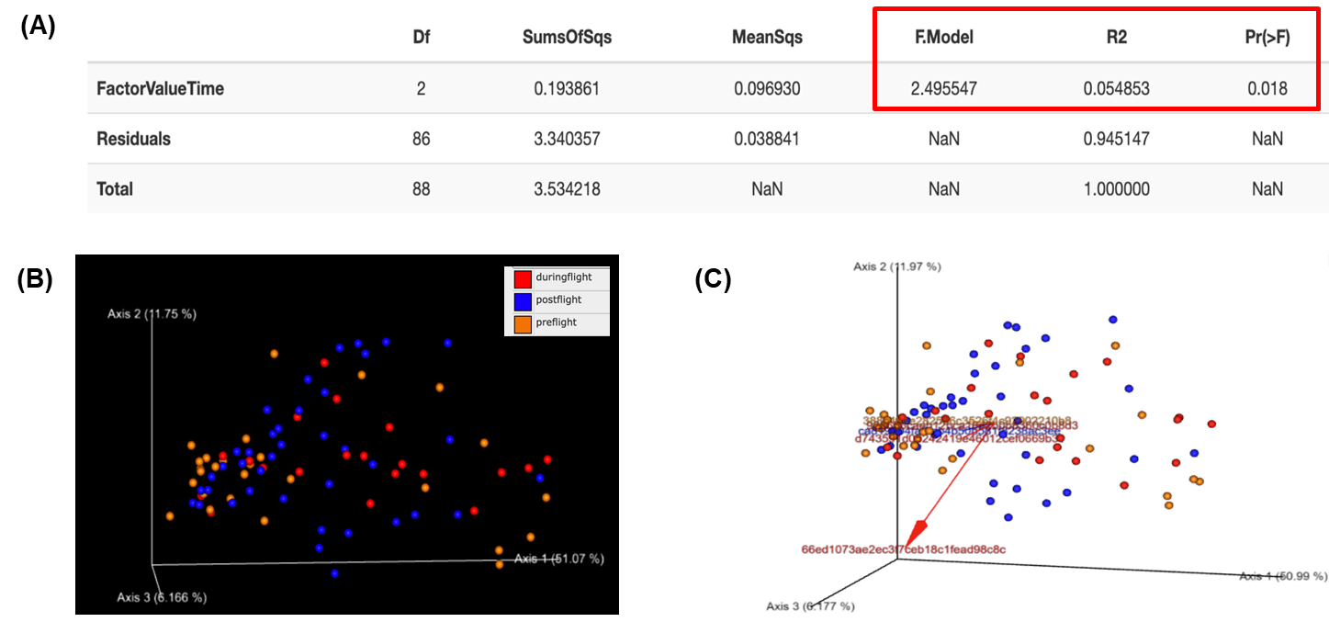

**Figure 5. Beta Diversity. (A)** Beta Diversity-Adonis Test grouped by flight time. Df, degree of freedom. F,Model is the ratio of the intergroup variance to intra-group variance. R2 is the fraction of variance between the samples explained by the grouping variable: flight time. **(B)** PCoA plot was created and visualized using Emperor. **(C)** PCoA Biplot showing the PCoA of Flight Time with a PCA of taxonomic features superimposed. The IDs mostly corresponded to the *Streptococcus* genus.

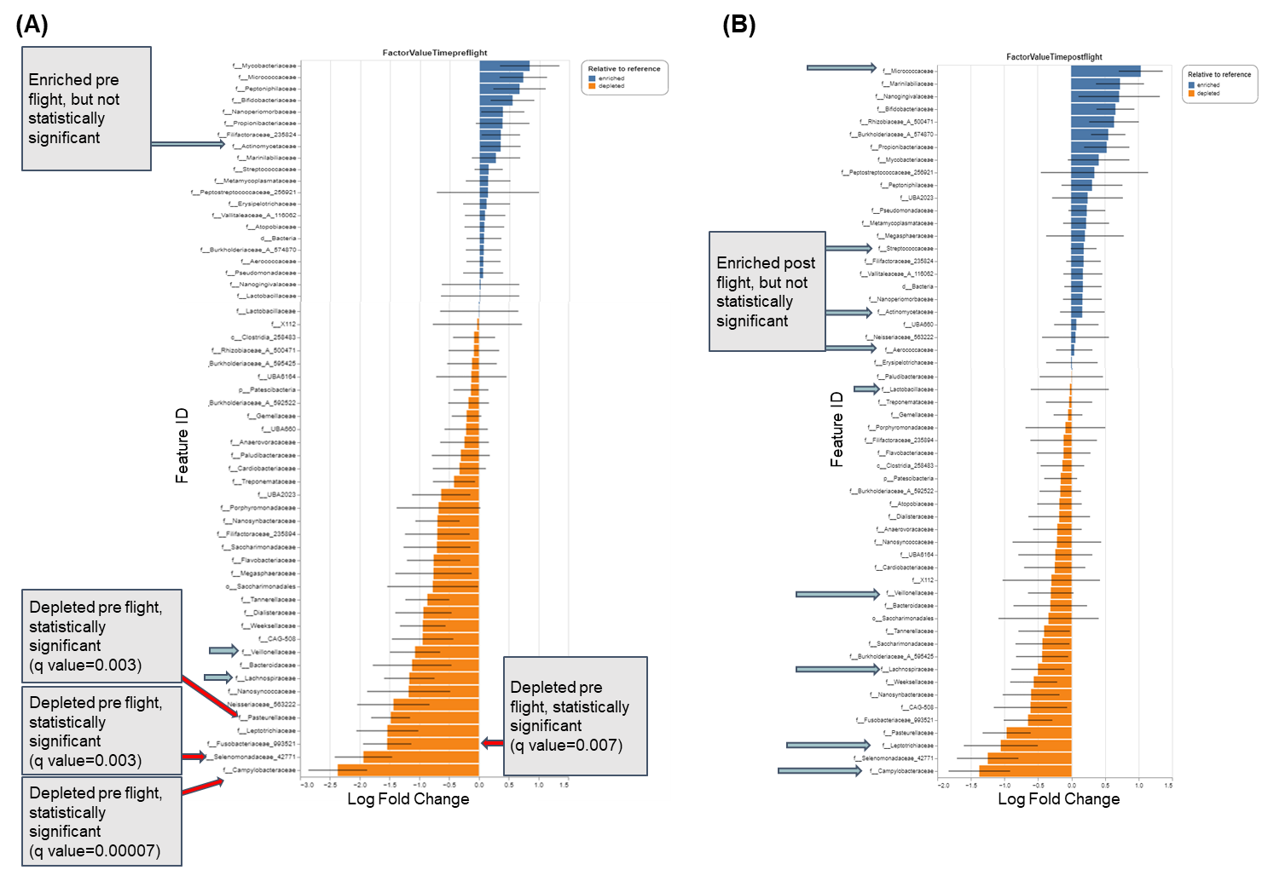

**Figure 6. Differential Abundance using ANCOM-BC.** x-axis represents the Log Fold Change in abundance and the y-axis represents the feature IDs at the family level. Blue or orange bars indicate enrichment or differential depletion, respectively. The statistically significant results are indicated by the red arrows and the blue arrows indicate the taxa identified in anxiety and depression oral microbiome research. During flight was chosen as the reference. **(A)** Differential expression, during flight vs pre-flight. **(B)** Differential expression, during flight vs post-flight.

The diversity analysis did not provide enough evidence of difference in the salivary oral microbiome between different flight times. However, differential abundance analysis, considering the compositionality of the microbiome, using ANCOM-BC provided insight into the taxa driving significant differences between the flight times at the family level (**Fig 6**). Using during flight as a reference, the taxa enriched or depleted in pre-flight and postflight groups were identified. While many taxa were differentially abundant in the comparisons (p value < 0.05), most of the taxa could not reach statistical significance when corrected for multiple testing (q value > 0.05). There were no significant results when comparing post-flight with respect to during flight (**Fig 6B**). However, when comparing pre-flight with respect to during flight, Pasteurellaceae (-1.479025), Selenomonadaceae (-1.937014), Campylobacteraceae (-2.368843) and Fusobacteriaceae (-1.538565) were significantly depleted pre-flight as compared to during flight (**Fig. 6A**) with log fold changes of -1.479, -1.937, -2.369 and -1.539 respectively. While only four taxa were statistically significant, multiple taxa identified in the analysis above as differentially abundant have previously been identified as being associated with anxiety and depression indicated by the blue arrows in **Fig. 6A and B**. Parallel to the differential abundance test using ANCOM-BC, we also analyzed the microbial differential abundance between during and pre- or post-flight by multiple T- tests (Mann Whitney Test) with 5% false discovery ratio for phylum level as well as family level. The data are shown in **Fig. 7**. The phyla Campylobacteriota and Proteobacteria were found to be differentially enriched during flight as compared to pre flight with a q value of 0.03. Actinobacteirota was enriched during flight as compared to post flight (q value =0.03) while Campylobacteriota and Proteobacteria were found to be depleted during flight as compared to post flight with q values of 0.02 and 0.03 respectively **(Fig. 7A and 7B).** At the family level, Campylobacteraceae was again confirmed to be enriched during flight as compared to pre flight with a q value of 0.02 (**Fig. 7C and 7D**). Similar to the results from ANCOM-BC, no significant results were obtained at the family level for a comparison between during flight and post flight. Analysis of Variance (ANOVA) specific for the Campylobacteraceae family also yielded statistically significant differences in abundance (**Fig. 7E**). However, these did not consider the compositionality of the microbiome and, therefore, the results from ANCOM-BC were given preference.

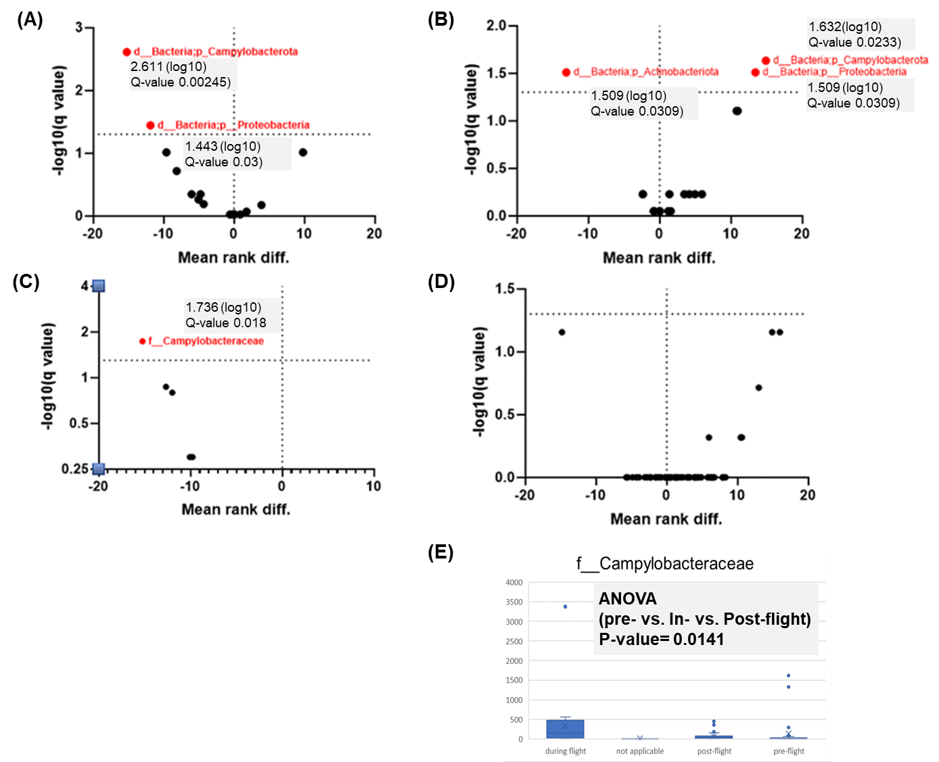

**Figure 7. Abundance Differences for specific Phyla and Family.** Multiple T-test, Mann-Whiney test (FDR 5%) **(A)** Phylum, during flight vs pre-flight **(B)** Phylum, during flight vs post-flight **(C)** Family, during flight vs pre-flight **(D)** Family, during flight vs post-flight **(E)** Family, differential abundance, specific to family Campylobacteracea.

**Discussion:**

Our study aimed to examine the differences, if any, between the salivary microbiome of astronauts using samples taken pre, during, and post space flight and compare our results to studies examining the microbiome of those with mental health disorders. Our results showed significant differences in the beta diversity, and differential abundance for the during vs pre-flight analysis. There was a statistically significant difference in beta diversity between the three groups (pre-flight, during flight and post flight) as indicated by the Adonis test results **(Fig. 5A)**. While the F statistic is more than 1, a higher intergroup to intragroup variance and higher R2 value, indicative of higher proportion of differences between samples being explained based on flight time, would help make a decisive conclusion. The lack of clustering pattern in the ordination plot further decreases the strength of the analysis **(Fig. 5B)**. The study found four families, Pasteurellaceae, Fusobacteriaceae, Selenomonadaceae, and Campylobacteraceae, that were significantly depleted in the pre-flight oral microbiome of astronauts as compared to the during flight samples **(Fig. 6)**. These results suggest that these four families are higher in abundance during spaceflight in comparison to pre-flight. Pasteurellaceae is a family that has pathogens critical for human health (Christensen, 2014). A previous study examined the salivary microbiome of individuals with and without depression (Wingfield et al. 2021). It was reported that the *Haemophilus* genus, belonging to the Pasteurellaceae family, is less abundant in those with depression (Wingfield et al. 2021). Therefore, the astronauts in our study could have had mental health issues pre-flight. However, since the present analysis was conducted at the family level, it is likely that the effect does not hold at the genus level.

Fusobacteriaceae was another family that was found to be depleted in preflight compared to during flight salivary samples **(Fig. 6)**. In a study examining the oral microbiome in adolescents for changes associated with depression and anxiety symptoms, Fusobacteriaceae, specifically the genus *Fusobacterium*, was found to be differentially abundant in studies between the groups. It was found that abundance of Fusobacteriaceae is positively correlated with depression (Simpson et al. 2020). Since Fusobacteriaceae is depleted pre flight as compared to during flight, or alternatively is more enriched during flight, this could indicate increased symptoms of depression amongst the astronauts during flight. Some studies have also shown the family Selenomonadaceae to be positively correlated with the Attention Deficit/Hyperactivity Disorder (Marx, 2022). Furthermore, the Campylobacteraceae family has previously been found to be enriched in those with bipolar disorder (Chen et al. 2022). However, no apparent association seems to have been identified for these families with depression and anxiety. While not statistically significant, our differential abundance analysis identified many more families to be enriched or depleted with respect to space flight, like Actinomycetaceae, Veillonellaceae, Leptotrichiaceae*,* that have been found to be correlated with depression and anxiety (Simpson et al., 2020). Also, Streptococcaceae had a high relative abundance for those with high anxiety symptoms (Simpson et al.,2020). However, it was found to be enriched pre-flight as compared to during flight in the present analysis with no significant results.

While there is some evidence of altered oral microbiome at different time points during a space mission and some of the identified taxa can be associated with depression and anxiety, based on previous literature, additional evidence is needed. In particular, future studies reviewing the fecal microbiome of astronauts to search for a possible connection between the microbiome state and mental health disorders would be beneficial. While fecal samples are more difficult to collect, especially in space, looking into the fecal microbiome might shed light on more interactions between the astronaut microbiome under space stressors and their mental health status. This is because some studies have reviewed the fecal microbiome signature associated with mental health status in different settings, including cancer (Zhu, J, et al. 2021). Simpson et al. previously used C reactive protein and cortisol levels as measures for symptoms of anxiety and depression (2020). Structured studies with astronaut health data would allow us to conduct multivariate analyses to directly compare the microbiome of astronauts with anxiety and depression, or any mental health disorder. This could help inform future expeditions and ensure better travel for those on long missions. One of the limitations of our research was the small sample size of the astronauts' salivary microbiome data. With an increased sample size and more research in both astronaut microbiome and anxiety and depression microbiome, a meta-analysis can be conducted. Meta-analysis will allow researchers to cross-compare information and see if their results are what they expected in relation to other studies' results (Guzzo et al. 1987). If there is some overlap in the sequencing method and data is publicly available, this could allow a comparison between anxiety and depression associated microbiome and astronaut microbiome, perhaps with the use of a model synonymous to the random effects model.

There is also a likelihood of bias associated with the salivary sample collection if any medications were taken by the astronauts that were not disclosed in the data. The ISS carries many drugs on board in case astronauts need certain medications (Seoane-Viano et al. 2022). Two classes of those drugs on the ISS are antidepressants and antipsychotics (Seoane-Viano et al., 2022). The present data did not disclose which, if any, drugs the astronauts were taking pre, post, or during flight (Urbaniak et al. 2020). Since there was no access to the personal records of the astronauts in the reference study from which the data was taken, astronauts could have been on medications that would impact their salivary microbiome, and thus the results. Given the many unknowns in both mental health related microbiome changes and space flight induced microbiome changes, it is imperative to continue looking into this area. Computationally, a machine learning classifier trained on data derived from anxiety and depression microbiomes could be fine tuned to the one associated with space flight data and be used to predict the mental health status of the astronauts. In our study, some significant differences were identified and could be related to mental health disorders, when compared to results from previous studies. It was concluded that the differential abundance of the taxa are more likely to distinguish between the different space flight times as compared to the diversity of the microbiome itself, something that was also found in the case of anxiety and depression microbiome by Simpson et al. in 2020. Therefore, the analyses conducted in our study enable us to investigate a novel question and generate the need to investigate many more.

**References:**

Bolyen, E., Rideout, J. R., Dillon, M. R., Bokulich, N. A., Abnet, C. C., Al-Ghalith, G. A., ... & Caporaso, J. G. (2019). Reproducible, interactive, scalable and extensible microbiome data science using QIIME 2. *Nature biotechnology*, *37*(8), 852-857.

Callahan BJ, McMurdie PJ, Rosen MJ, et al. DADA2: high‐resolution sample inference from Illumina amplicon data. Nat Methods. 2016;13:581‐583.

Carra A. Simpson, Christina Adler, Mieke R. du Plessis, Elizabeth R. Landau, Stuart G. Dashper, Eric C.Reynolds, Orli S. Schwartz, Julian G. Simmons,Oral microbiome composition, but not diversity, is associated with adolescent anxiety and depression symptoms,Physiology & Behavior,Volume 226,2020,113126,ISSN 0031-9384,https://doi.org/10.1016/j.physbeh.2020.113126.

Chen, Y. H., Zhou, C. H., Yu, H., Wu, W. J., Wang, Y. W., Liu, L., ... & Wang, H. N. (2022). Gut microbial signatures and differences in bipolar disorder and schizophrenia of emerging adulthood. *CNS Neuroscience & Therapeutics*.

Christensen, H., Kuhnert, P., Norskov-Lauritsen, N., Planet, P. J., & Bisgaard, M. (2014). The family Pasteurellaceae.

Guzzo, R. A., Jackson, S. E., & Katzell, R. A. (1987). Meta-analysis analysis. *Research in organizational behavior*, *9*(1), 407-442.

Lin, H., Peddada, S.D. Analysis of compositions of microbiomes with bias correction. Nat Commun 11, 3514 (2020).

Mars, K. (2021, February 3). What happens to the human body in space? NASA. Retrieved May 1, 2023, from https://www.nasa.gov/hrp/bodyinspace

Marx, J. (2022, February 7). Differences in the microbiota of patients with ADHD (attention deficit/hyperactive disorder). Eat2BeNice. Retrieved April 30, 2023, from https://newbrainnutrition.com/differences-in-the-microbiota-of-patients-with-adhd-attention-deficit-hyperactive-disorder/

Smart D. Radiation Toxicity in the Central Nervous System: Mechanisms and Strategies for Injury Reduction. Semin Radiat Oncol. 2017 Oct;27(4):332-339. doi: 10.1016/j.semradonc.2017.04.006. PMID: 28865516; PMCID: PMC5657507.

Seoane-Viano, I., Ong, J. J., Basit, A. W., & Goyanes, A. (2022). To infinity and beyond: Strategies for fabricating medicines in outer space. *International Journal of Pharmaceutics: X*, 100121.

Simpson, C. A., Adler, C., du Plessis, M. R., Landau, E. R., Dashper, S. G., Reynolds, E. C., ... & Simmons, J. G. (2020). Oral microbiome composition, but not diversity, is associated with adolescent anxiety and depression symptoms. *Physiology & Behavior*, *226*, 113126.

Urbaniak, C., Lorenzi, H., Thissen, J., Jaing, C., Crucian, B., Sams, C., ... & Mehta, S. (2020). The influence of spaceflight on the astronaut salivary microbiome and the search for a microbiome biomarker for viral reactivation. *Microbiome*, *8*(1), 1-14.

Voorhies, A.A., Mark Ott, C., Mehta, S. et al. Study of the impact of long-duration space missions at the International Space Station on the astronaut microbiome. Sci Rep 9, 9911 (2019). <https://doi.org/10.1038/s41598-019-46303-8>

Wingfield, B., Lapsley, C., McDowell, A., Miliotis, G., McLafferty, M., O’Neill, S. M., ... & Murray, E. K. (2021). Variations in the oral microbiome are associated with depression in young adults. *Scientific Reports*, *11*(1), 1-9.

Zhu, J., Li, M., Shao, D., Ma, S., & Wei, W. (2021). Altered fecal microbiota signatures in patients with anxiety and depression in the gastrointestinal cancer screening: a case-control study. *Frontiers in Psychiatry*, 1832.